Case 18-AM,C-Taino-Tripointer-Early-Three levels

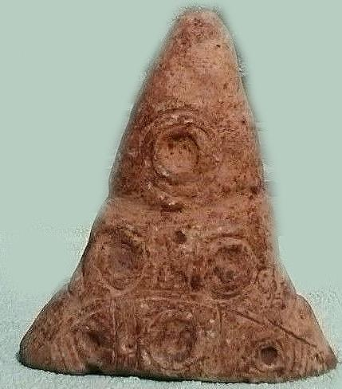 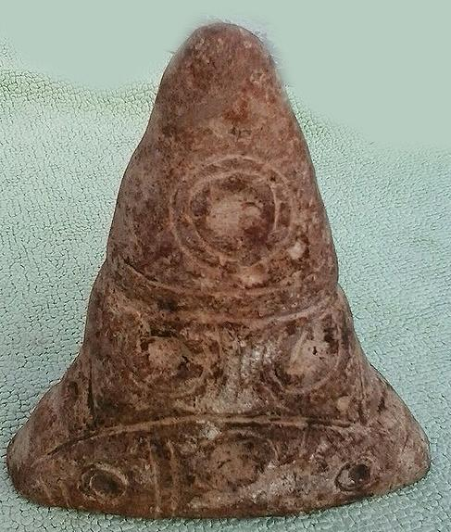 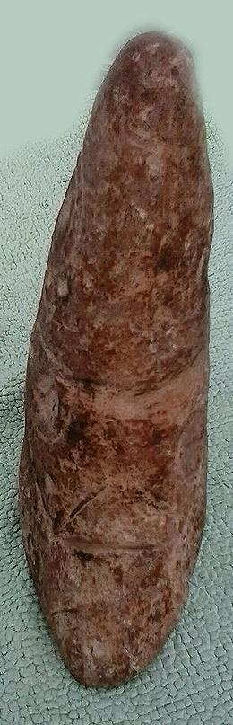

Type 5. 7.5 by 6 by 2 inches; country of origin, Dominican Republic.

In Type 5 the designs are a central cupules with two concentric circles surrounding it. This symbolism signifies life. There are six of these symbols on either side. The upper cupule is separated from two lower cupules by two circular lines that encompass the conoid. The two middle cupules are separated from the three lowest cupules also by two inverted circular lines. Perhaps what is being expressed here is a tripartite, living universe, the upper sky, the middle, earth, the lower cupules signifying the nether or dark regions. This appears to conform to the iconography implicit in other artifacts we shall examine, especially pendants.

### Delivery package 1 of 1

Estimated delivery Thursday, Jan 7, 2016 - Monday, Jan 11, 2016

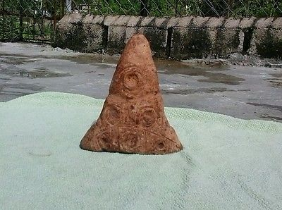

#### [Taino Three Pointer Pre Columbian](http://www.ebay.com/itm/151930092500)

|  |  |
| --- | --- |
| Item price | $99.00 |
| Quantity | 1 |
| Item number | 151930092500 |
| Shipping service | FedEx International Economy |

## Shipping address

Ralph J Coffman Jr

149 Atlantic Ave

Swampscott MA 01907-2427

United States

## Order total

|  |  |
| --- | --- |
| Subtotal | $99.00 |
| Shipping | $80.00 |

**Total**

$179.00